

Lab Manual

Subject: Machine Learning

Course Code AI-414

By

Mohammad Mukedas 2023-BS-AI-008

Supervised by Sir Saeed Degree name: BSAI-4A

DEPARTMENT OF COMPUTATIONAL SCIENCE

Table Of Content

Project 1:Paris Housing Price Prediction 3

1. Data Collection: 3

2. Data Preprocessing: 3

3. Feature Selection: 3

4. Model Training (Linear Regression): 3

5. Prediction: 4

6. Expected Output: 4

Program: 4

Project 2: Mushroom Classification Using Classifier 13

Program: 14

Project 1:Paris Housing Price Prediction

Description:
This project involves predicting the price of houses in Paris using a regression algorithm. The dataset includes features like the number of rooms, size (square meters), floors, and location details. These features are used to train a Linear Regression model that can estimate the price of a house.

Tools & Technologies:
- Python
- Pandas, NumPy (for data handling)
- Scikit-learn (for regression models)
- Matplotlib / Seaborn – for data visualization (optional but useful)

How It Works:

Data Collection:

Load the Paris Housing Dataset containing real estate features and prices.

Data Preprocessing:

Handle missing values (if any)

Normalize or scale the data if needed

Convert categorical data (if present) into numeric form

Feature Selection:

Use columns like:

Number of rooms

Square meters

Floors

District/location info

Model Training (Linear Regression):

Train a Linear Regression model using the training data to learn the relationship between features and house prices.

Prediction:

Test the model using unseen data to predict house prices based on input features.

Expected Output:

The system will accurately predict the price of houses in Paris when provided with features like area, rooms, and location details. The output will be a continuous value (price in Euros).

Program:
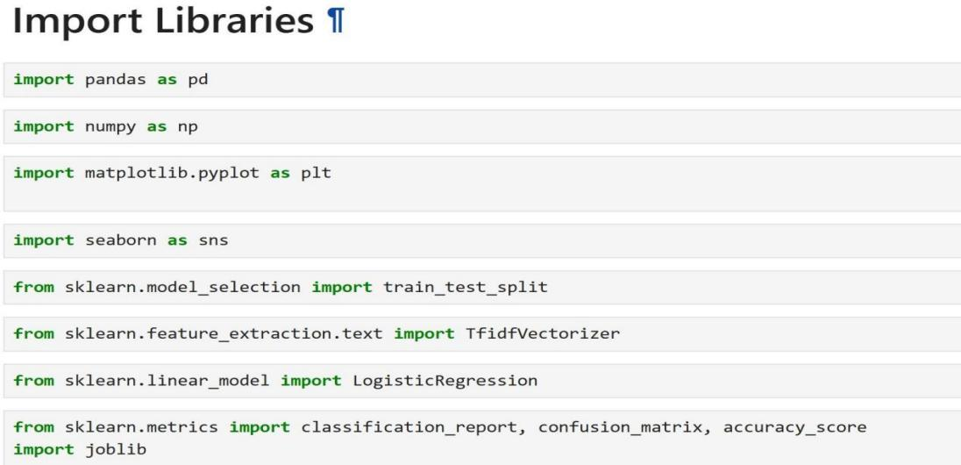

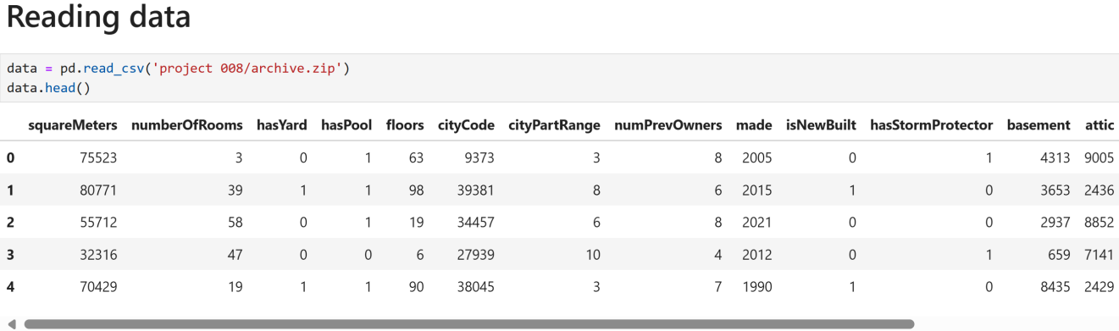

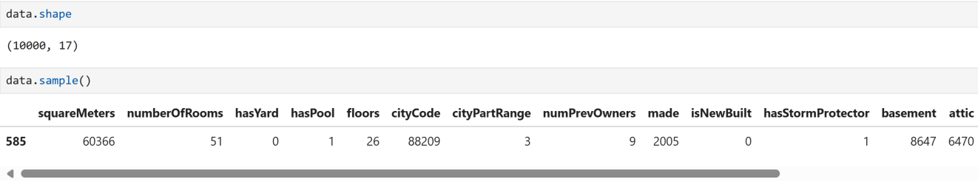
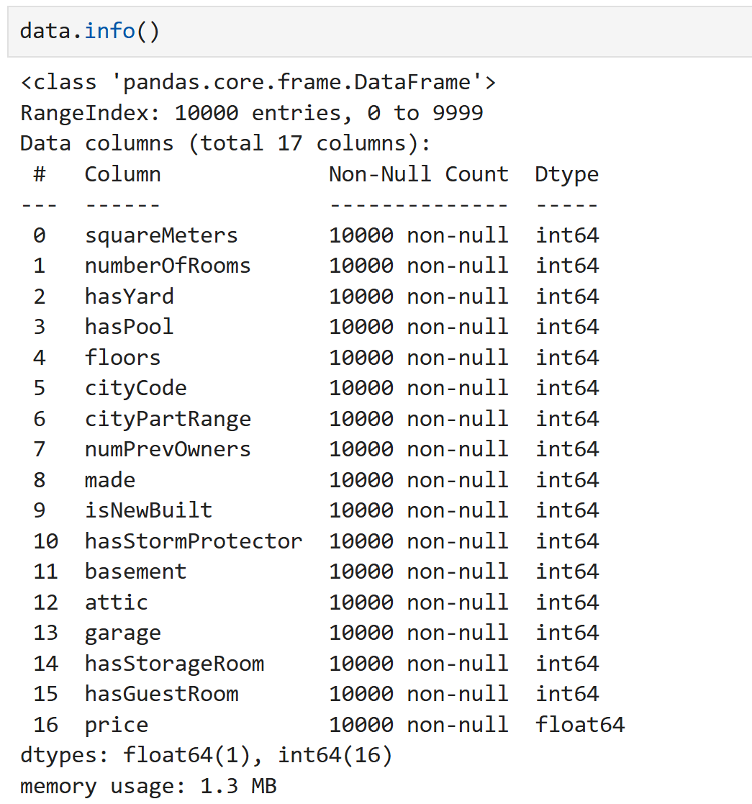

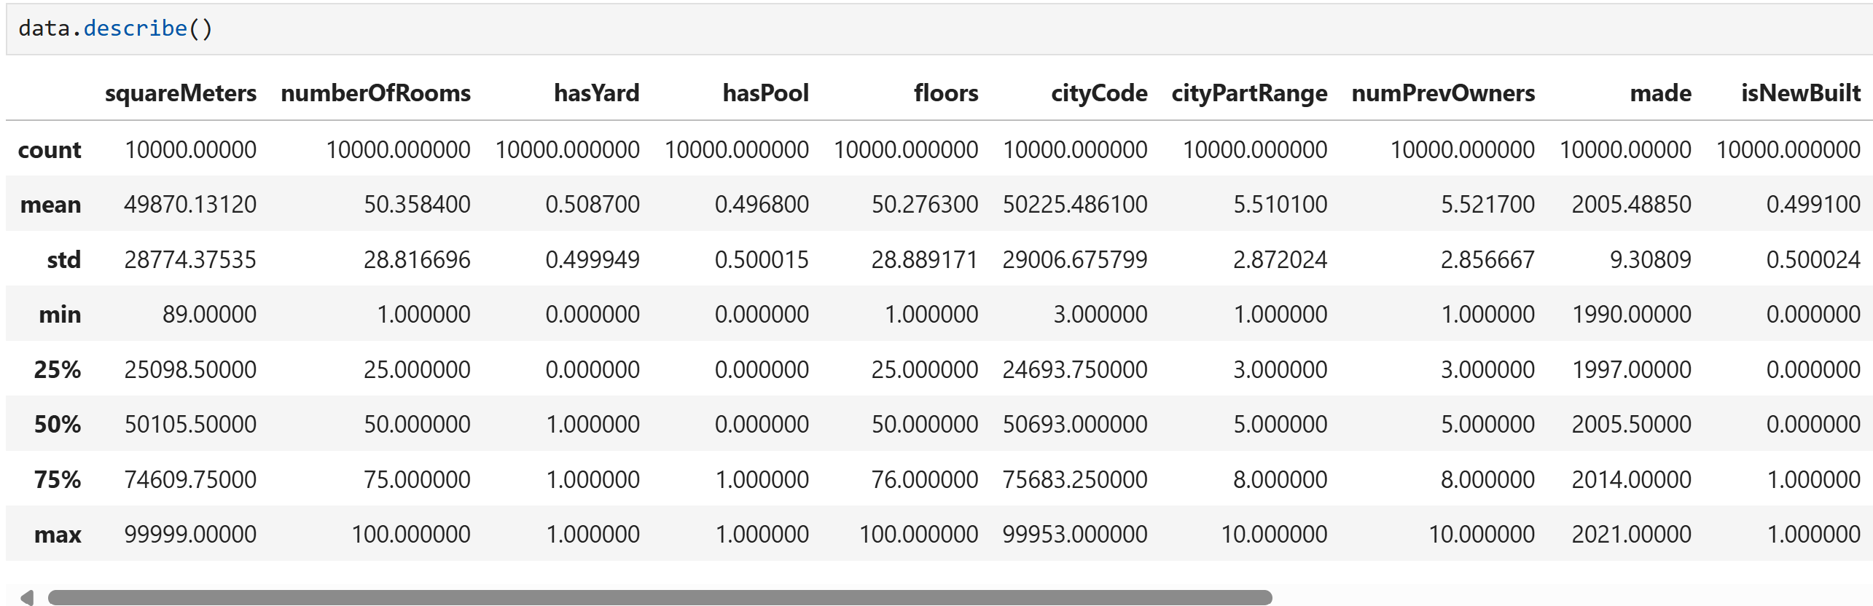

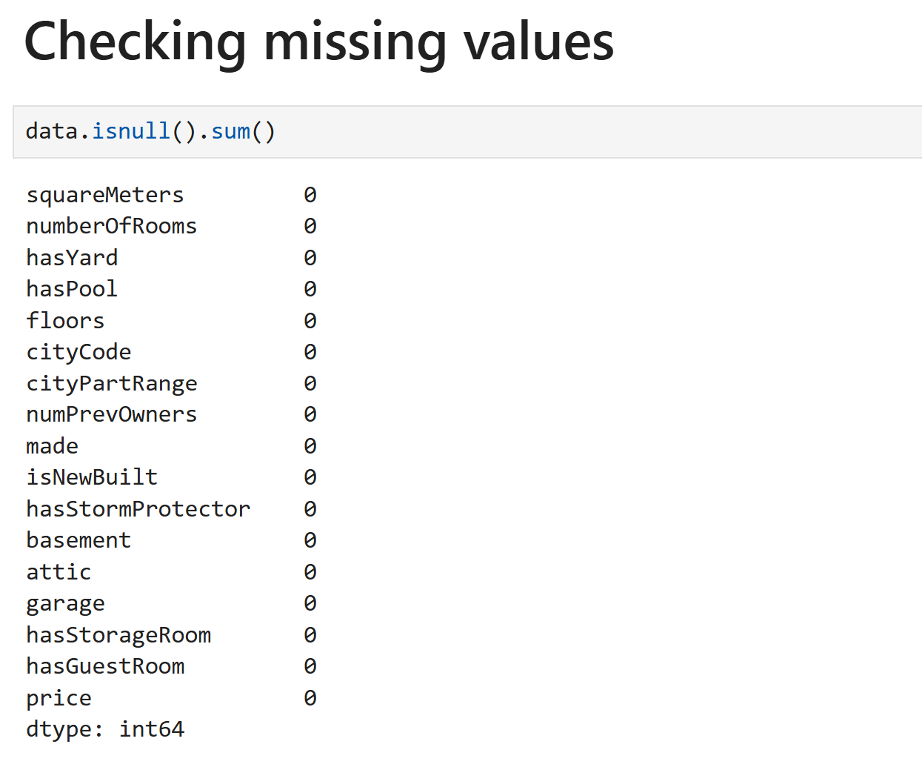
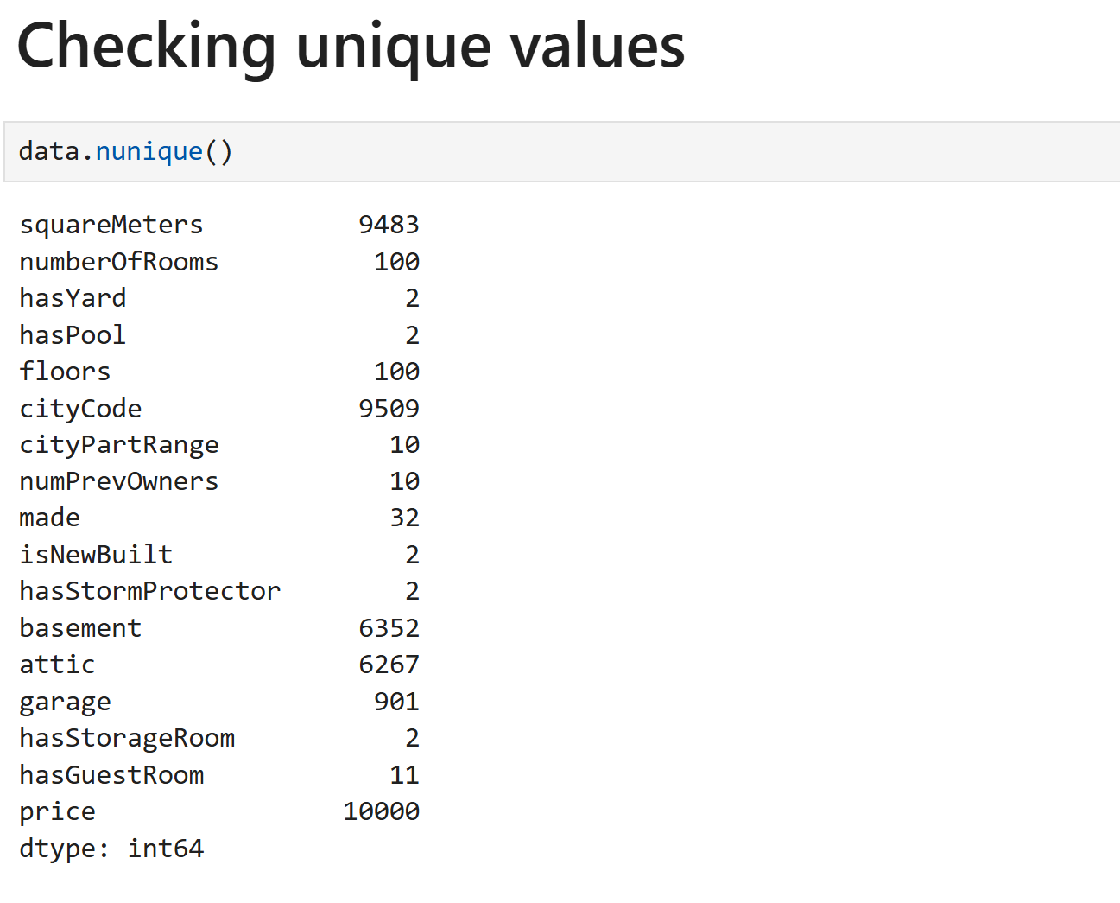

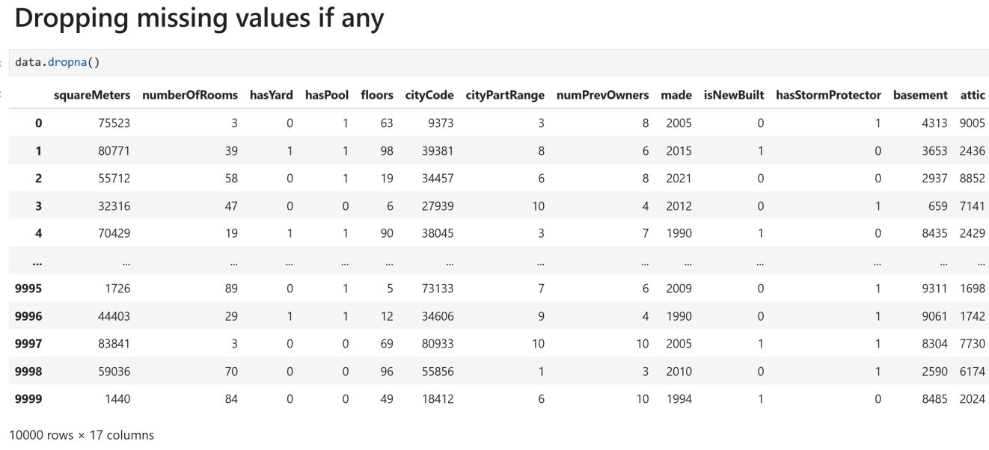

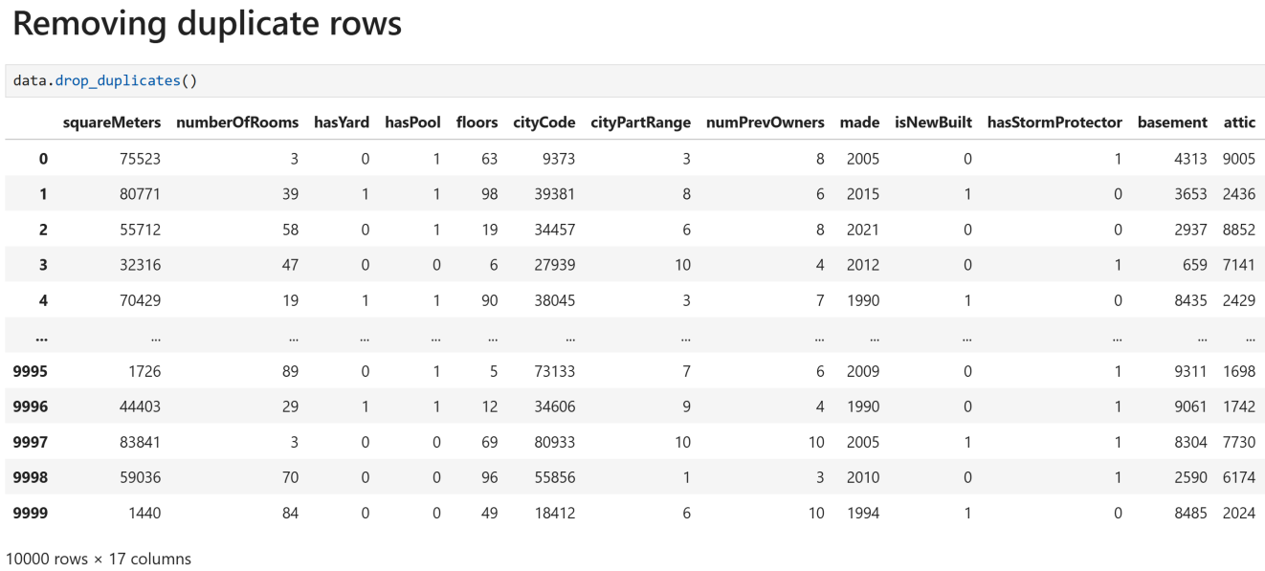
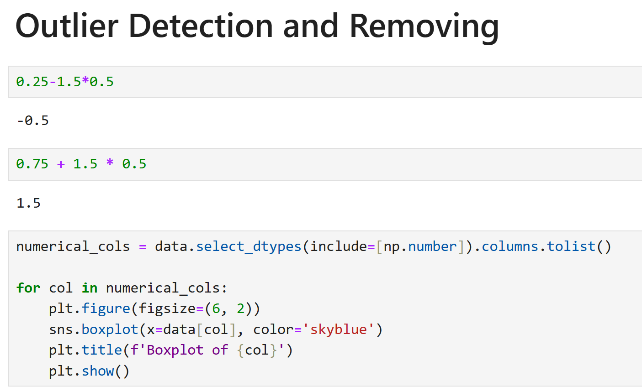

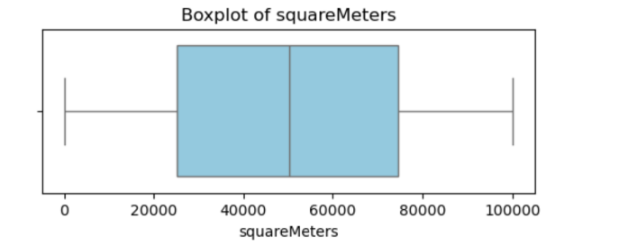
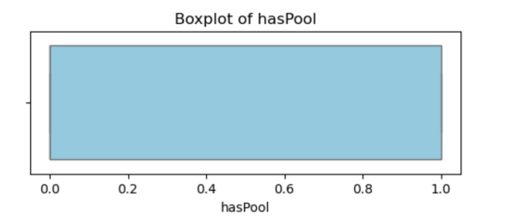

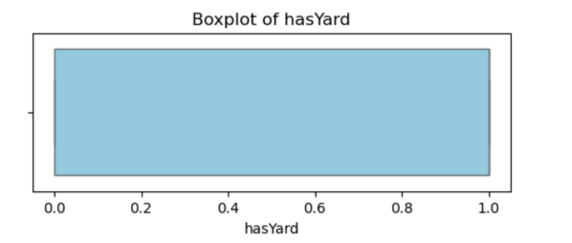
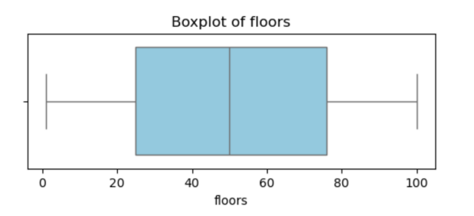
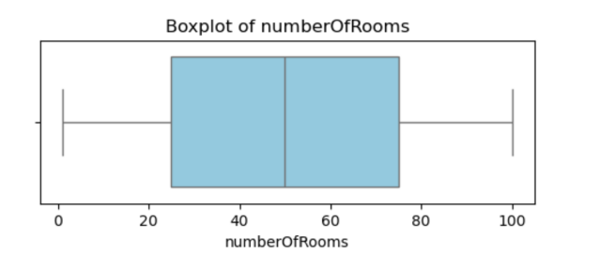
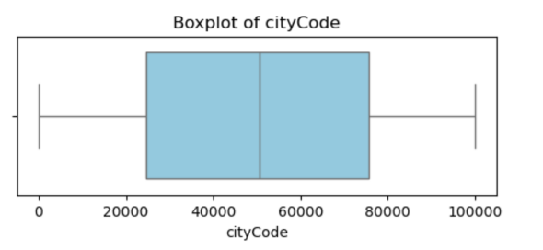

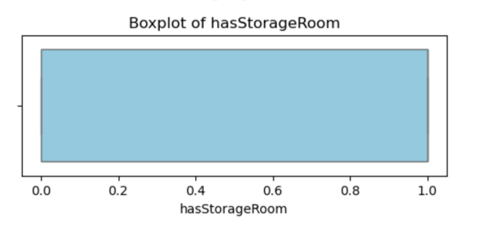
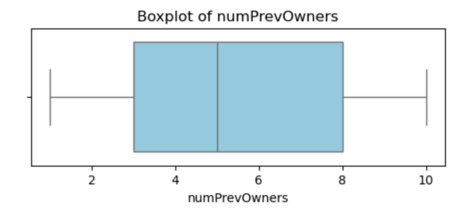

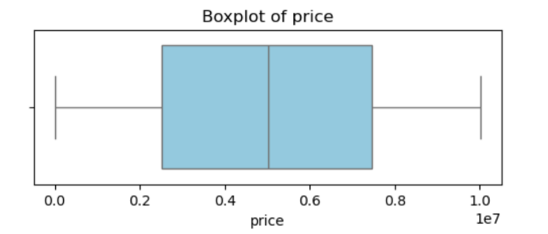
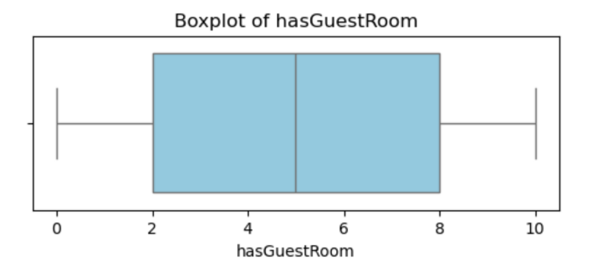
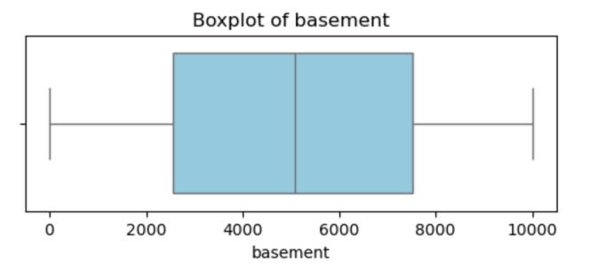
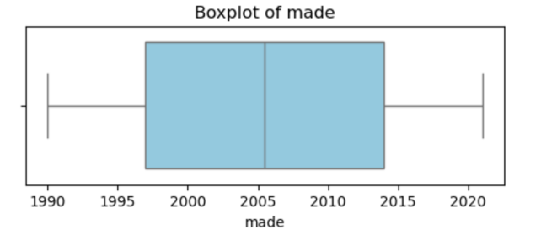
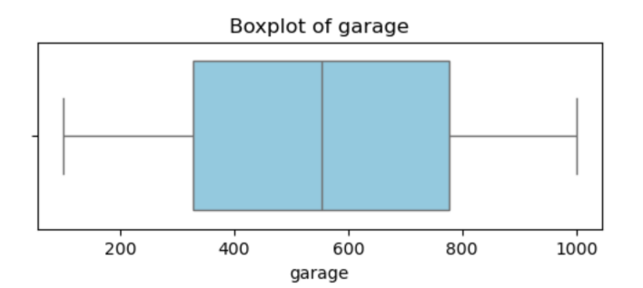
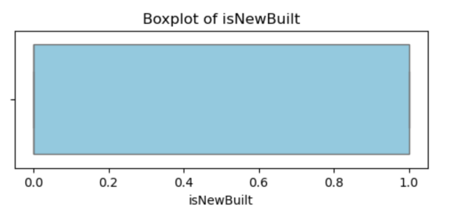

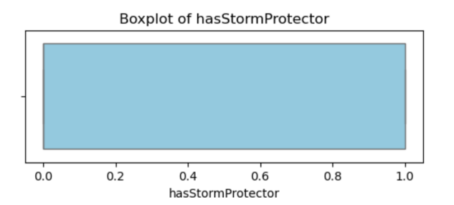

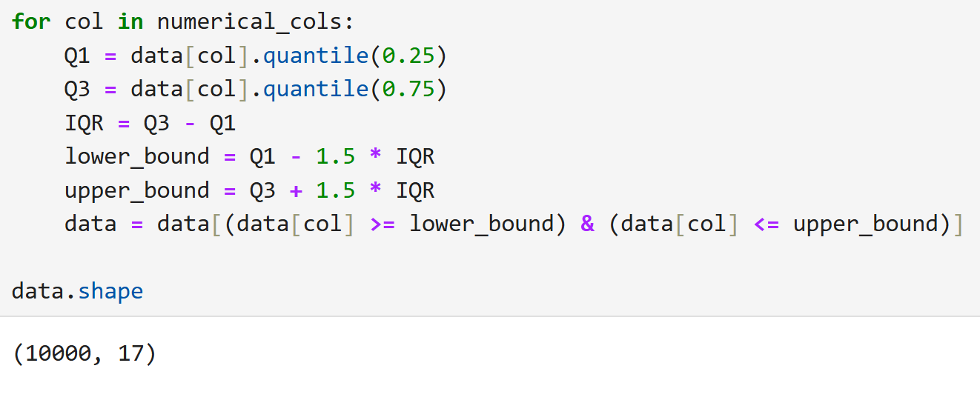

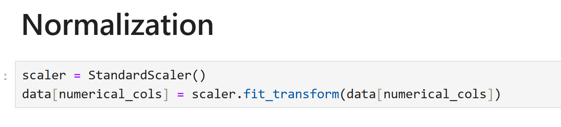

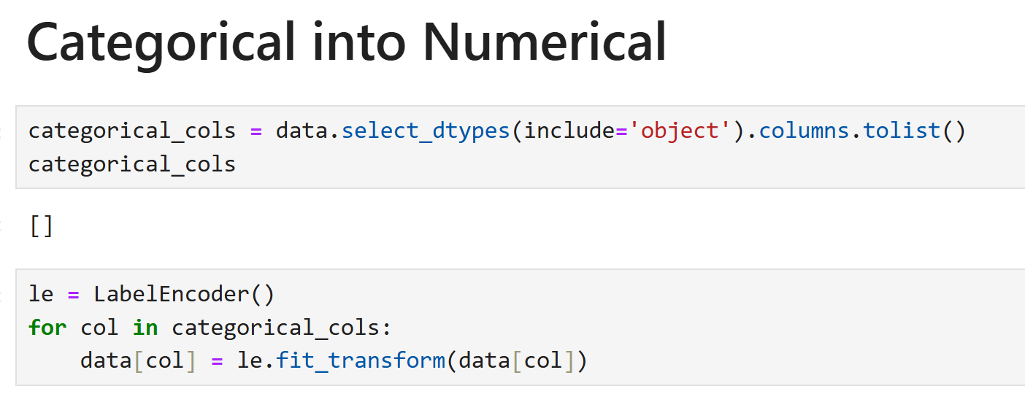

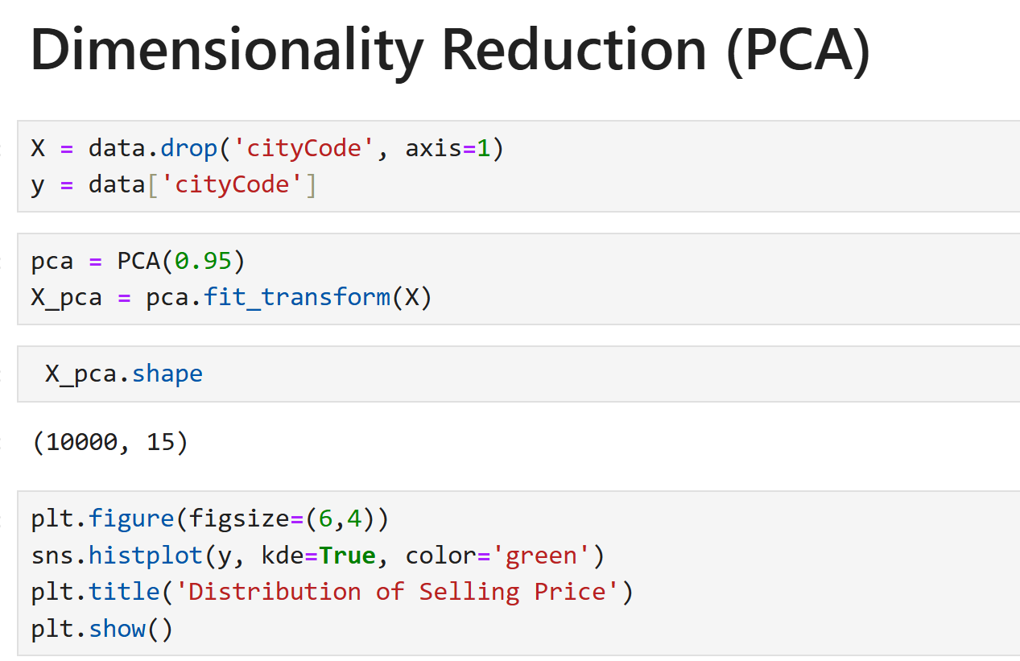

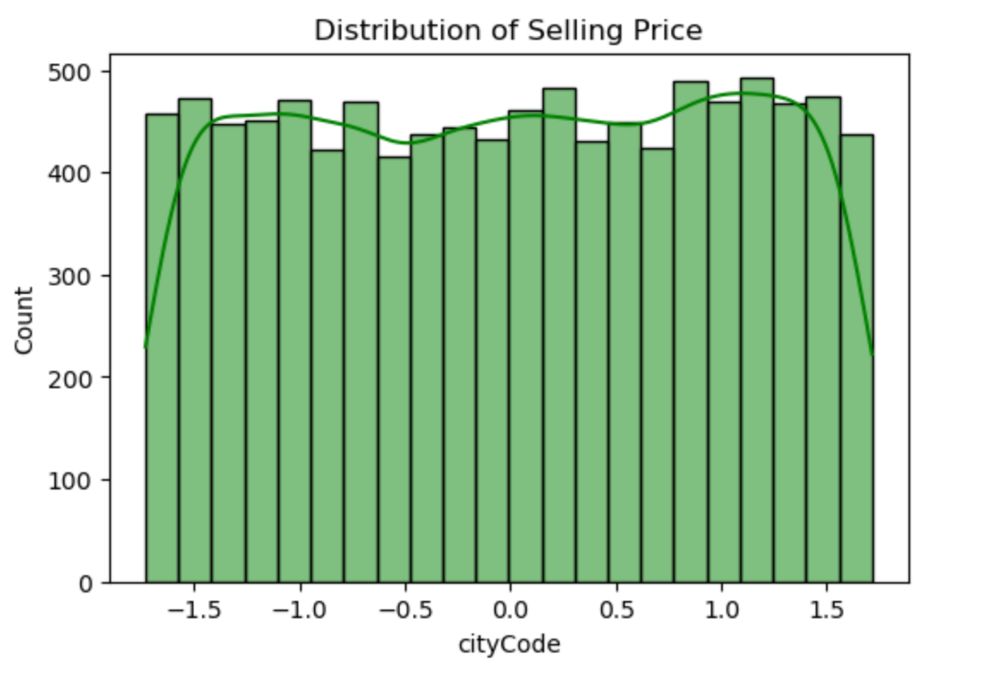

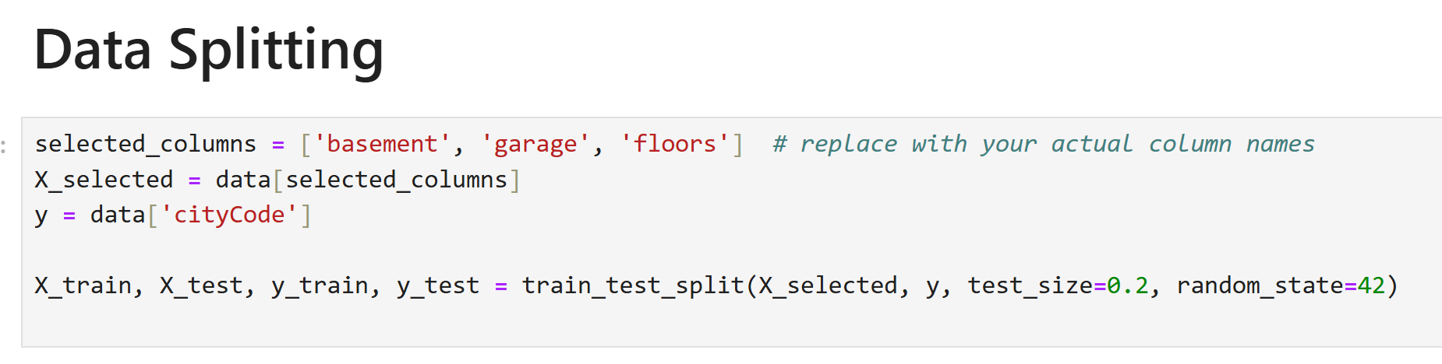

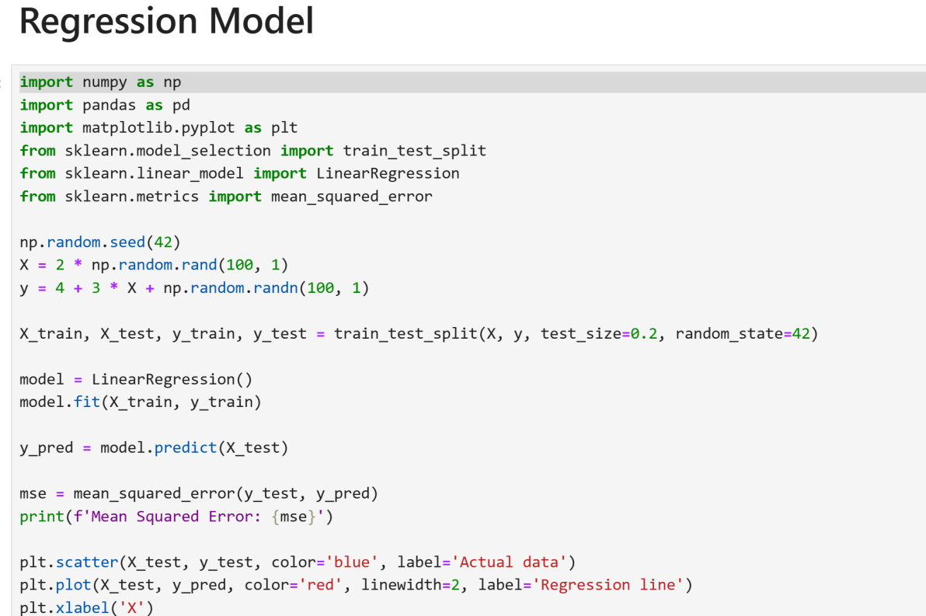

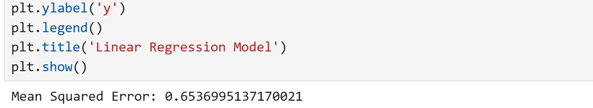

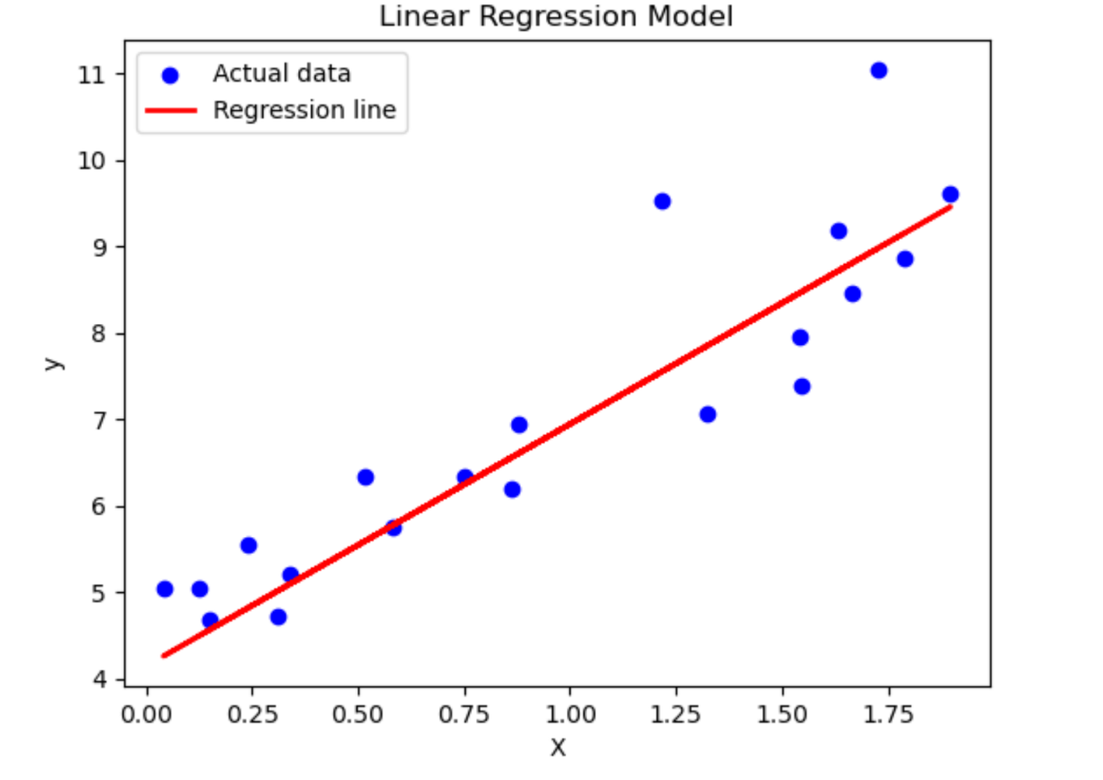

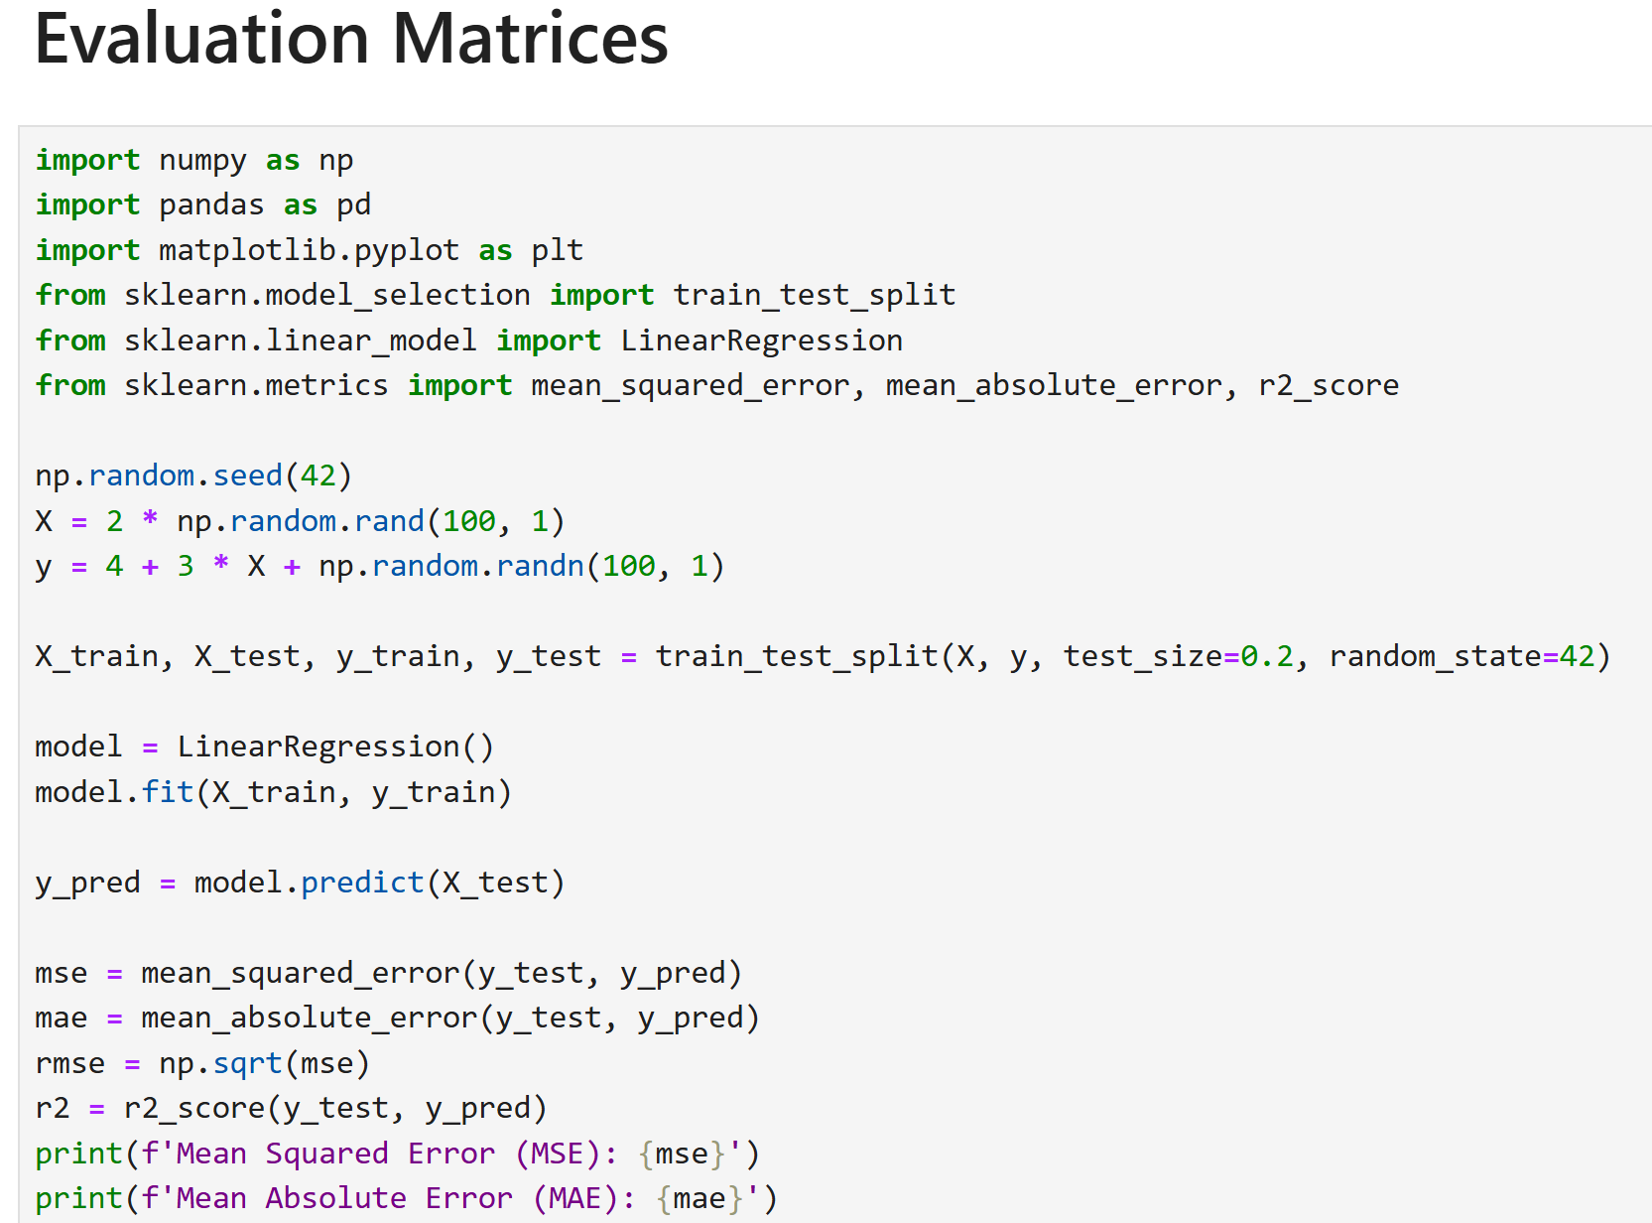

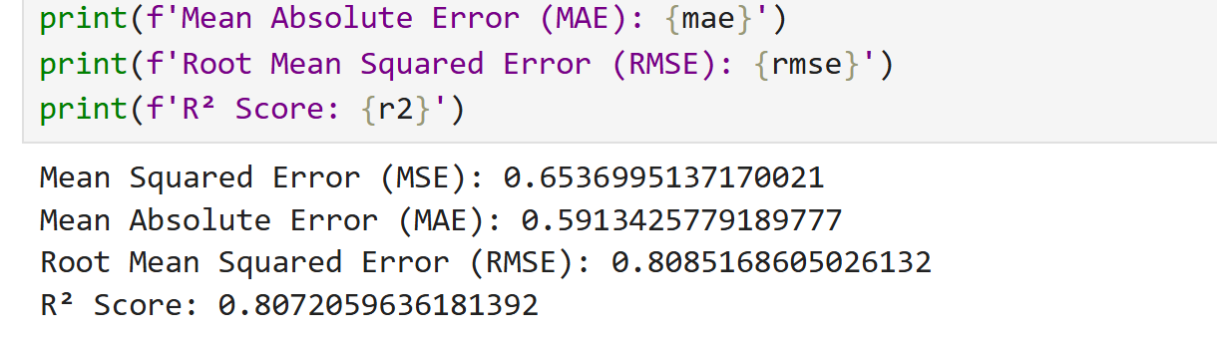

Project 2: Mushroom Classification Using Classifier

Introduction:
In this project, we will examine the data and build
different machine learning models that will detect if the mushroom is edible or poisonous by its specifications like cap shape, cap color, gill color, etc. using different classifiers.

Dataset:
The dataset used in this project is that contains 8124 instances of mushrooms with 23 features like cap-shape, cap-surface, cap-color, bruises, odor, etc.

The python libraries and packages we’ll use in this project are namely:

- NumPy
- Pandas
- Seaborn
- Matplotlib
- Graphviz
- Scikit-learn

We’ll use the specifications like cap shape, cap color, gill color, etc. to classify the mushrooms into edible and poisonous.

Program:
